Chapter 1, Problem 6.

The charge entering a certain element is shown in Fig. 1.23. Find the current at:
(a) t = 1 ms (b) t = 6 ms (c) t = 10 ms

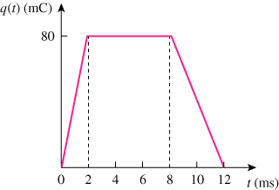
30

Figure 1.23
For Prob. 1.6.

